Seacoast Church Guidelines for Campus Growth
Fall 2011

Introduction
Since opening our first offsite campus in the spring of 2002 Seacoast has seen thousands of people added to our church family. We have seen clearly that God has called us to continue to open campuses across South Carolina and beyond to reach as many people as we can as quickly as we can with the Good News of the Gospel. In fulfilling this call we have also seen the need for a framework on which to build the future of Seacoast Church; that is the purpose for these Guidelines for Campus Growth. While these guidelines are intended to inform and shape our decisions as we look to the future, this is a living document which will grow and change as God provides new challenges and opportunities. The bottom line is that everything be done “decently and in order” as we continue to fulfill God’s purpose for Seacoast on earth.

Mission and Core Values

Mission
The mission of Seacoast Church is to help people become fully devoted followers of Christ. We work toward this vision by presenting the good news of the gospel to the unchurched, uncommitted, and unconvinced of our community in a fresh, relevant way.

Core Values
Seacoast Campuses emphasize the following core values:
- Authenticity
- Externally focused
- Practical teaching
- Worship that is Spirit filled, contemporary and led with excellence.
- Relaxed, non-threatening atmosphere
- Children’s ministry that is fun and inviting.
- Relational life groups that foster community and discipleship.
- We are one church, many campuses

Strategy

Identification
In identifying a new campus we look at three factors:
- The right people.
Key people in starting a campus (hired internally or externally, depending on situation)
  - Campus Pastor
In addition to the qualifications of 1 Timothy 3 a Campus Pastor should have the following traits:
    - Recognized leader in his circle of influence
    - A team builder
    - Developer of other leaders
    - Heart of a pastor
    - A passion to reach the community where the new campus will be located
    - Entrepreneurial
  - Worship Leader
    - Chosen by the Campus Pastor in agreement with the Worship Arts Champion
  - Children’s ministry director
    - Chosen by the Campus Pastor in agreement with the Family Ministry Champion
  - Life Group Coach
    - Chosen by the Campus Pastor in agreement with the Life Group Champion
- The right place
The key factors in finding the right place are
  - Are there people in the area with a connection to Seacoast?
  - Is there a need in the community for a church like Seacoast?
  - Are the demographics conducive to a church like Seacoast?
  - Is the campus located in a growing community?
- The right time
A Seacoast campus is ready to birth a new campus when…
a. They have multiple weekend services
b. They are experiencing significant crowding in their prime time service(s)
c. They can financially absorb the loss of attendees to launch a new campus
d. The main leadership for the new campus has been identified

Ideal times for starting a new campus
  - Beginning of the year
  - Easter
  - Fall (After school starts)

Building the Core
Once the key leader or Campus Pastor has been identified the following strategy is followed.
- Campus Pastor
A new Campus Pastor generally undergoes at least three months of training in Mt. Pleasant before being sent to their campus. Training consists of books, life classes, hands on experience and immersion in Seacoast DNA.
- Core group
The second step is to start a life group. The purpose of the life group is to build a core of leaders for the new campus. Life group members come from people with Seacoast connections, their acquaintances and people the Campus Pastor draws. The group meets weekly for vision casting, relationship building and outreach.
- Café
Once the Core Group reaches 20-30 adults they move to the Café stage. A medium size space is secured for weekly celebration meetings (life church services) and the group divides into 2 or more life groups. The Pastor continues to meet weekly with the key leaders. At the weekly celebrations all of the life groups come together for worship, teaching and children’s ministry.
- Campus
Once the Core Group reaches 60 - 80 committed adults, they are ready for the Campus Launch, which ideally begins with 250-350 people on day one. Preferable time from Core Group to Campus is six months.

Launching the Campus
Successfully launching a new campus requires the coordination of many key elements. Timing is essential for success. Key elements include:
- Site selection
Choosing the wrong site can cripple a new campus. An ideal site will
  - Seat a minimum of 300 people. This will allow the campus to grow to over 500 people in two services before having to consider a new site.
  - Have space for 60 children divided into 4 areas.
  - Have parking for 200 cars
  - Have high visibility in a growing area, surrounded by housing developments. Same rules as a good retail space.
  - Rent for less than $3600 per month
- Leadership team
Key leaders must be in place, trained and have their teams in place in the following positions:
  - Worship Leader
  - Children’s Director
  - Technical Director
  - Life group coach and leaders
  - First Touch leader (Parking, greeting, ushers, bookstore and café)
  - Setup/tear down team leader
  - Financial team leader
  - Administrative Assistant

In the beginning only the Campus Pastor, Administrative Assistant and Worship Leader are paid positions. The Worship Leader may be a part time position depending on the plant. As the campus grows other leaders are hired. Some musicians may be hired on an as needed basis. Refer to the Staffing Matrix for additional details.
- Equipment and supplies
Purchased and on hand four weeks before launch date. Purchases are generally made through Central Support and equipment is setup and tested prior to delivery. Equipment is broken down into the following areas:
Low High
  - Technical (Sound, lights, video, stage, storage) $30,000 $50,000
  - Children’s (Tables, chairs, dividers, rugs, toys, etc.) $ 6,000 $10,000
  - Lobby (Bookstore, Café, Information Center) $ 2,000 $5,000
  - Supplies (Bulletins, offering envelopes, curriculum, growth track materials) $ 2,000 $5,000
Total $40,000 $70,000
- Marketing
The Campus Operations Team will create a marketing plan for each campus. The plan may include one or all of the following elements:
Low High
Signage
Signs need to be large, clear and portable. All signs will be approved and distributed by Central Support. $2,000 $4,000
Mail out
20-40,000 direct mail pieces are sent to the surrounding zip codes 1-2 weeks before the launch $5,500 $8,000
Radio/Newspaper
Ads are run 1 week before and the week of the launch $3,000 $8,000
Personal Invitations
These are printed and distributed to core team and to other campuses. They are handwritten and hand addressed to friends who live in the area. $ 700 $2,000
E-vites
E-vites are made available on the Seacoast website. $ 0 $0
Community events
Informational picnics and gatherings, and similar functions. $ 500 $1,000
Letters
Letters are sent to everyone in the Seacoast database from that area. Typically $12,000 is to be spent on marketing. Depending on the market, this may be adjusted. Seacoast Central Support is responsible for all marketing of a campus before it starts up. $ 500 $1,000
Totals $12,200 $24,000
- Practice and Launch services
  - Setup service 1 (Launch minus 3 weeks)
    - Set everything up, plug everything in
    - Create a list of needs and fixes
    - Tear everything down and put into storage
  - Setup service 2 (Launch minus 2 weeks)
    - Set up
    - Run through as many service elements as possible
    - Tear down and store
  - Practice service (Launch minus 1 week)
    - Set up
    - Run through a full service
    - Tear down and store
  - Launch service

Campus operation
Central Support
The idea of Central Support is to move as much of the administrative tasks from the campus to the church. These include: weekend service messages, video support, human resources, information technology, accounting, banking relationships, annual auditing services, cash management, to name a few.

We prefer to have the campus pastors and administrative staff spend their time ministering to the needs of the congregation rather than taking time with administrative functions. The funds which are part of the campus budget are assessed on a monthly basis and only on the tithe income of the campus.
- Common areas
To maintain the Seacoast DNA at each campus, the following areas are the same at each campus:
  - Weekend services: The format at each campus will be similar in style, substance and length. 75% of worship music will come from a shared catalog of songs.
  - Inside Track: Each campus will offer the same basic growth track with synchronized scheduling when possible. Elements include
    - Newcomers. First full weekend of the month
    - Behind the Scenes. Connecting attenders with service opportunities; second weekend of the month
    - Life Groups.
    - Leadership Classes (Leading Yourself, Leading Others, and Leading Leaders)
  - First Wednesday Monthly Worship and Communion service
  - Naming conventions
The following names are in common at each campus
    - Kidscoast (Children’s ministry)
      - Hidden Cove (0-24 months)
      - Little Ark (2-3 years)
      - Treasure Island (4 years)
      - Adventure Beach (5 years)
      - Harbor Towne (1st-5th grade)
    - Nitro (Middle school)
    - Life Groups (Rather than Small Groups, Care Groups, Community Groups, etc.)
    - Information Center
    - First Wednesday
    - Newcomers
    - First Touch Team (Greeters, parkers, ushers, bookstore, and cafe)

- Variables
A great deal of variety exists between campuses. Variables include
  - Wednesday nights. Other than First Wednesdays campuses are free to use the midweek in a way that works best for their needs.
  - Life groups. Life groups can choose a wide range of topics to organize around. There is no set time for life groups. We operate on a free market concept.
  - Discipleship events. Each campus can offer discipleship courses in a variety of formats as the need arises.
  - Special elements in the services such as special music, occasional videos, etc.
  - Missions. Missions are centrally planned and coordinated on an annual basis. Please contact the Missions Pastor for details on trip details.
  - Special events and projects
  - Programs. Not all campuses will have the same ministries once you get outside of Family Ministry. What programs and ministries will be decided between the campus pastor, their regional pastor, and the COO. Campus size, demographics, age, needs, and other factors are taken into account.
- Ministry accountability
Each campus is operated under the leadership of the Campus Pastor. Central Support operates in the role of support, consultant, encouragement in concert with the Campus Pastor on that area of ministry, but each local ministry leader is accountable to the Campus Pastor. The driving theme is “One church many campuses”.

- Authority flows from Senior Pastor through Executive Team to Campus Pastors
- The role of the Senior Pastor, Executive Team and Campus Pastors is to keep all of the campuses under the same vision (roof)
- The role of the Central Support team is to keep all of the campuses on the same foundation.
- The vision is the Seacoast DNA; the foundation is agreed upon Seacoast practices.
The “roof” leads the campuses; the “foundation” supports the campuses.

- Team Relationships
As one church many campuses we operate as teams across campus boundaries. Team relationships are illustrated below:

 | Teams
 | Central support | Campus 1 | Campus 2 | Campus 3
Team Leaders | Campus Operations Pastor | Campus Pastor | Campus Pastor | Campus Pastor
 | Administrative Assistant | Administrative Assistant | Administrative Assistant | Administrative Assistant
 | Children’s Pastor | Children’s Director | Children’s Director | Children’s Director
 | Life Groups Pastor | Life Groups Coach | Life Groups Coach | Life Groups Coach
 | Worship Pastor | Worship Director | Worship Director | Worship Director
 | Communications Pastor | Communications Director | Communications Director | Communications Director

Financial
- Assumptions
- Our financial model is designed for each campus to be self-sustaining within the first twelve to fifteen months. Three guidelines in all financial decisions are:
  - Maximize impact while minimizing risk or regret
  - Think big, plan conservative
  - Financially, campuses are managed as businesses
- No individual campus will be allowed to negatively impact the financial health of Seacoast Church. A campus is considered to have a negative impact beyond repair when, after twelve to fifteen months, it has a bottom line of -$25,000.
- Long term obligations will be entered into cautiously and must be approved by the trustees of Seacoast Church. A campus that is not self-sustaining within 18 months of launch may be closed or may require other changes to their financial budgets except under special circumstances.
- In order to launch a minimum of two campuses per year, Seacoast Central Support (CSC) must have $200,000 available in a separate reserve account.
- Startup costs
Startup costs are funded from Seacoast Central Support to the new campus and encompass only budgeted startup expenses incurred prior to the launch. Budget for a startup includes:
Low High
Purchase of equipment $40,000 $70,000
Marketing leading up to the launch $12,000 $24,000
Six months of salary for the campus pastor prior to the launch. $18,000 $43,000
Lease of space prior to launch $ 3,000 $5,000
Administrative Assistant may be added prior to launch.
When a café is begun, salary for worship leader, band members, $ 2,000 $8,000
Budgeted startup costs per campus $75,000 $150,000
- Operating Budget
All income and expenses after launch are charged to the operating budget. The operating budget is set by multiplying expected average attenders by expected average giving. In most cases the beginning budget is set on the following formula:

250 attenders times $750 per person/per year = $187,500

We recommend that campuses set their budgets at 90% of projected income to provide a positive cash flow for the campus. Below is a recommended breakdown of a budget for a startup campus:

Seacoast Church campus plant budget overview
Typical Distant Campus Budget
Income
Attenders | 250
Giving | $ 750
Projected income | $ 187,500
*Budget | $168,750
Expense | Percentage | Amount
Payroll & Benefits | 38% | $ 64,125
 | 12% | $ 20,250
Rent expense | 20% | $ 33,750
Ministry expense | 10% | $ 16,875
Central Support expense | 20% | $ 33,750
Total | 100% | $ 168,750
Local Campus Budget
Income
Attenders | 350
Giving | $ 750
Projected income | $ 262,500
*Budget | $ 236,250
Expense | Percentage | Amount
Payroll & Benefits | 38% | $ 64,125
General expenses | 12% | $ 20,250
Rent expense | 20% | $ 33,750
Ministry expense | 10% | $ 16,875
Central Support expense | 20% | $ 33,750
Total | 100% | $ 168,750
The average total investment for a startup campus ranges between $125,000 and $150,000. This amount will depend on a number of factors including location, estimated campus size, marketing amount, how soon staff is brought onto the Seacoast staff, and final equipment specifications.

All expense categories, except the Central Support, are adjustable from one category to another as deemed necessary by the regional pastor, COO, and the campus pastor.

Category explanation:
- Compensation:
This is the total of salaries of all persons paid by the campus, insurance benefits, housing allowance, and employment taxes, retirement contributions, and other benefits
- Operating costs:
Utilities, cleaning expense, maintenance & repair, equipment expense, printing, supplies, etc.
- Rent:
Rent payments, storage units, office space, CAM fees, and other facility related expenses
- Ministry:
These expenses include Children, life groups, adults, students, outreach, seminars, leader training, educational resources, travel, business meals, etc.
- Central Support:
20% of the campus budget goes to Central Support to cover administrative costs. This includes the following areas but may not be a complete list

- Weekly video tape of weekend message and all supporting materials
- Weekend materials
- IT support
- Financial guarantees
- Monthly accounting services
- Leadership training
- Technology assistance
- Ministry training
- Children’s ministry support and curriculum
- First Touch support
- Life group support
- Human Resource assistance
- Web site
- Marketing assistance
- Graphic templates
- Access to Seacoast Intranet
- Budgeting assistance/financial planning
- Bookkeeping
- Database maintenance
- Other agreed upon administrative support

- Budget process
  - Startup budget
Startup budget is set by the Business Office. Once approved, all purchases will be coordinated through Central Support.
  - Operating budget
Operating budget is set by the Regional and Campus Pastor in consultation with the Business Office. Budgets are reviewed quarterly with Regional Pastor, Campus Pastor, COO, and the Business Office and adjusted according as needed.
  - Positive cash flow
All Campuses must budget for a minimum10% cash flow on the bottom line at the end of their first full year of operation.

Growth Expectations
- Campuses
- All Campuses should grow in attendance yearly. A distance campus is expected to grow in attendance a minimum of 10% per year, while a local campus should grow 15% per year.
- Overhead should lag growth of campus.
- No new hire until growth in attendance has happened over a period of at least 6 months. Hires need to be approved in advance and follow the approved guidelines from the People Resources Department. Refer to the Staffing Matrix for additional details.
- Hub & Spoke Development Strategy
- A Hub Campus is vibrant with high growth. It has an average attendance of 400+ and 24/7 presence in the community (Office Space).
- A Spoke is a campus that is launched from a Hub location. The core team develops at the Hub. The Campus Pastor and leadership usually form at the Hub as well
- Facility Leases
  - Startup campus building leases are generally no longer than one year.
  - On continuing Spoke Campuses, we should commit to no more than a 2 year lease.
  - On continuing a Hub Campus lease, we will commit to no more than a 5 year lease.
  - Emphasis will be placed on short term liquidity & long term flexibility.

- Guidelines to Purchase Land/Building
  - Must be a Hub Campus and have launched at least one Spoke
A Seacoast campus is ready to launch a spoke when…
- They have multiple weekend services
- They are experiencing significant crowding in their prime time service(s)
- They can financially absorb the loss of attendees to launch a new campus
- The main leadership for the new campus has been identified
  - Campus goals have been consistently met or exceeded
  - Any upfit or purchase must be fully supported by a campus capital campaign prior to upfit or purchase
  - Must be open for at least two years from launch of campus. Trends take time to develop and a church takes time to grow. We wouldn’t want to build too early and confine God by the box that we build
  - Must be approved by Seacoast Executive Team
  - Must be approved by Seacoast Board of Trustees if debt or additional leases are required
  - A projected budget needs to be developed, reviewed and approved by the Central Support Business Office before submitting to the Seacoast Board of Trustees for approval. This budget needs to include all aspects of the new space (utilities, furniture, phones, security, etc.). Forecast models for the next several years are generally required to set a path to judge performance against in future years.

In the event that an existing church is potential gifting their assets to Seacoast Church as part of becoming a Seacoast campus, these are some of the factors which must be considered prior to going forward:
- Location (Is the property in an area where Seacoast is considering opening a campus?)
- Long term debt of existing church (Any assumption of assets should have a neutral or positive effect on the overall financial picture of Seacoast.)
- Operating cost (Are they currently operating with a positive cash flow?)
- Environment of existing church
- Organization of existing church
- Compatibility with Seacoast Church

The process for considering these filters is as follows:
- CSMT and Senior Pastor informed of a potential merger.
- Preliminary meeting with the pastor/governing body and members of the CSMT.
- An agreement, outlined by the Business Office, with the governing body to go forward with a study and timeline for the potential merger.
- CSMT outlines the study and brings the necessary people to the table to find the answers needed. These people could include the following:
  - Ministry leaders
  - Church attorney
  - CPA firm & auditors
- CSMT decides whether to pursue or not pursue the merger
- Merger taken before the Executive Team and approved or disapproved
- Merger taken before the Seacoast Trustees and approved or disapproved
- Seacoast Senior Pastor gives final approval or disapproval
- Merger approved or disapproved by the governing body of the merged church.
- Church is reopened as a Seacoast campus.

- Central Support
  - Seacoast Central Support Infrastructure is expensed and financed by 20% of a campuses tithe income
  - Central Support cannot grow at a faster rate than the tithe income of the campuses as a whole
  - Central Support accumulates and dispenses all outreach funds

Campus Goals
- The health of a campus is measured in the following categories:
  - Average attendance (adults and total)
  - Average life group attendance
  - Total number of life groups
  - Baptisms
  - Newcomers attendance
  - Average weekend volunteers
  - Per adult giving

- The following is a template of what a healthy campus would look like during the first year in each of the categories above:
  - Local Campus
Average total attendance 350
Average Weekly Life Group Attendance 50% of total adult attendance
Baptisms 10% of total adult attendance
Newcomers attendance 3% of total adult attendance per month
Average weekend volunteers 15% of total adult attendance per week
Per adult giving $750

b. Distance Campus
Average total attendance 250
Average Weekly Life Group Attendance 50% of total adult attendance
Baptisms 10% of total adult attendance
Newcomers attendance 3% of total adult attendance per month
Average weekend volunteers 15% of total adult attendance
Per Person Giving $650

Helping a Campus in Crisis
One or more of the following warning signs indicate a campus is entering crisis stage mode:
  - Missed opening attendance goal. The goal for a local campus is 350 people and 250 people for a distance campus
  - A net loss of $25,000 after the first year
  - Annualized tithes are less than $750 per person for a local campus and less than $650 per person for a distance campus
  - Life Group attendance is less than 30% of total attendance
  - Leadership Failure
  - After one year, weekly attendance is less than 150 people for a distance campus and less than 250 people for a local campus
  - Monthly Newcomers attendance consistently falls below 2% of total church attendance
When it is determined that a campus is in crisis mode the following steps will be taken
  - A team is sent to the campus to assess the situation
  - Growth plan objectives are set by the team
  - A growth plan with milestones is agreed on by Campus Pastor and Pastor of Campus Development
  - Campus Pastor meets monthly with Pastor of Campus Development to give updates on the growth plan
  - Assessment team makes a second visit
  - Assessment team reports on progress
  - Campus is measured against warning signs above
If a campus remains in crisis mode after the above process is completed one of the following three steps will be taken with the approval of the CSMT and Exec Team:
  - The campus will be closed down and the campus pastor either released or relocated to another campus
  - The campus will be closed as a Seacoast campus but continue to operate as an independent entity under a new name
  - The campus will be given additional time to come out of crisis mode and then reassessed.

Administration
- Reporting
Campuses submit the following reports schedule:
  - Every Monday a report on attendance and tithes for the weekend
  - Once a month a report of life group attendance, number of weekend volunteers, baptisms, first time commitments and worship team participation.
  - Quarterly campus budgets are reviewed to ensure that the campus is on track financially. The budget may be adjusted at this time with the approval of COO, Regional Pastor and the Campus Pastor.

- Meetings/connecting times
First Tuesday of the month
9:30 a.m. Campus pastor teleconference (Post-launch campuses)

Second Tuesday of the month

Third Tuesday of the month
(Campus Pastors meet with Regional Teams in their regions this week)
8:30 a.m. Seacoast Central Support Management Team

Fourth Tuesday of the month
9:30 a.m. Various team meetings (Campus Pastors, Family Ministry teams, Worship teams, First Touch teams, etc from all campuses
11:00 a.m. All Staff meeting & lunch; time for our staff to engage in a service. Worship is lead by a campus worship team, a time for our Senior Pastor to pour into the staff, and a shared lunch

Weekly Individual meetings with each campus pastor and their staff

Monthly All Staff meeting

Quarterly Meetings with Campus Pastors and Central Support staff to do budget reviews. Meetings include COO, Business Office staff, Campus Pastor & Regional Pastor

Organizational Chart Addendum

Structure
Campuses are overseen by Central Support which is accountable to the Executive Team of Seacoast Church. The Board of Trustees of Seacoast Church functions as trustees for each campus. Campus pastors are accountable to their Regional Pastor.

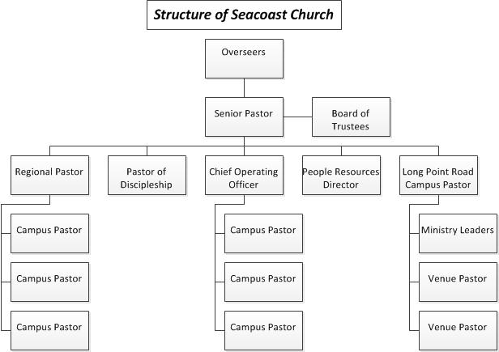

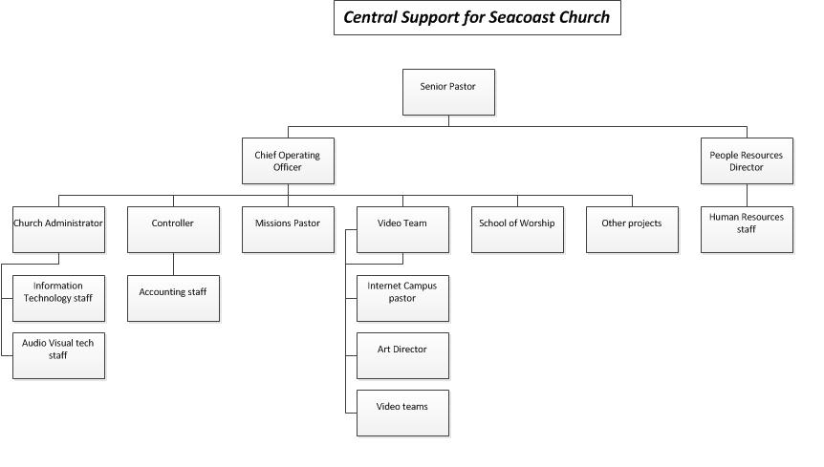
The current structure for Seacoast Central Support is:

The organization structure for a life campus is as follows:
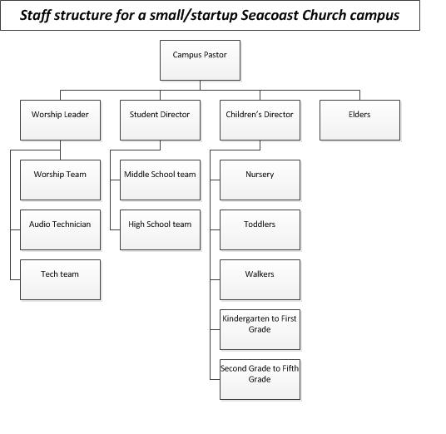

The organization structure for a mid-size campus is as follows:

